ThingsEye Diagnosis App
User Manual
— NB-IoT / LoRa Device Diagnostic Link Guide

Supported Versions:

Windows Installer Version / Windows Portable Version / Mac Portable Version

Table of Contents

Table of Contents 2
Ⅰ.Product Overview 4
Version Notes 4
Ⅱ.App Versions and Operating Modes 5
Ⅲ.Login and Diagnosis Portal 6
Ⅳ.NB-IoT Device Diagnostic Links 7
4.1 UDP Forward 7
4.2 TE Integration 7
4.3 TE Converter 8
4.4 TE Device 8
Ⅴ.LoRa Device Diagnostic Links 9
5.1 ChirpStack 9
5.2 ChirpStack Uplink 9
5.3 TE Integration 9
5.4 TE Converter 9
5.5 TE Device 10
VI.Diagnostic Link Modules and Color Meaning 11
Ⅶ. Integration / Converter Debug and Events Explanation 12
7.1 Diagnostic Logic 12
7.2 Events Display Rules 12
Ⅷ. Link Diagnosis and Troubleshooting Sequence 13
8.1 LoRaWAN Devices 13
8.2 NB-IoT Devices 13
Ⅸ. Examples of Diagnostic Status 14
9.1 Examples of NB-IoT Device Diagnostic Statuses 14
9.1.1 NB-IoT: Entire Link Shows “Pass” (Green) 14
9.1.2 NB-IoT: First three sections show “Pass,” TE Device shows blue “Pass”(offline) 15
9.1.3 NB-IoT: Integration/Converter (Yellow) — No Event, but the device passed 16
9.1.4 NB-IoT: Entire Link Shows Red “Fail” 17
9.1.5 NB-IoT: UDP Forwarder Pass, but Downstream Links Fail 18
9.1.6 NB-IoT: UDP Forwarder Pass, but Downstream Links Fail 19
9.2 Examples of LoRaWAN Device Diagnostic Statuses 20
9.2.1 Integration/Converter shows yellow“No Event,” but the device shows“Pass” 20
9.2.2 LoRa:Full-Link Green Pass 21
9.2.3 LoRa: Integration/Converter shows yellow “No Event,” device shows blue “Pass”(offline) 22
9.2.4 LoRa: ChirpStack Registered, but Uplink and Subsequent Links Fail 23
9.2.5 LoRa: ChirpStack Registered, but Uplink and Downstream Links Fail with No Device Event 24

Ⅰ.Product Overview

The ThingsEye Diagnosis App helps users quickly identify data link connectivity issues with their devices. After logging in with their ThingsEye master tenant account and password, users can choose between NB-IoT device diagnostics and LoRaWAN device diagnostics.
Based on the device type, the system automatically checks the entire data link—from device onboarding and platform integration to data conversion and storage in the ThingsEye database—and displays the status of each step using different colors and icons.
Version Notes
For Windows, both a portable version (no installation required) and an installer version are currently available; for Mac, only the portable version (no installation required) is currently available. To officially distribute the Mac version, Developer ID signing and notarization are required to reduce Gatekeeper security prompts and address slow startup times.
Due to privacy-related integration issues with the multi-platform backend during the diagnostic process, device queries are currently supported only for the primary tenant administrator account. Users with subordinate accounts should contact the primary administrator for diagnostic assistance.

Ⅱ.App Versions and Operating Modes

Platform Type | Version Type | Delivery Files | Operating
Windows | Installed Version | ThingsEye_Diagnosis_Setup_1.0.1_x64.zip | Double-click the installer to complete the installation, then open the program from the Start menu or a desktop shortcut.
Windows | Portable Version (No Installation Required) | ThingsEye_Diagnosis_Portable_1.0.1_x64 | After extracting the files, double-click ThingsEye Diagnosis.exe to run the program.
Mac | Portable Version (No Installation Required) | ThingsEye Diagnosis-1.0.1-arm64-mac | After extracting the files, double-click ThingsEye Diagnosis Core to run the program.

Ⅲ.Login and Diagnosis Portal
- Open the ThingsEye Diagnosis App and go to the login page.
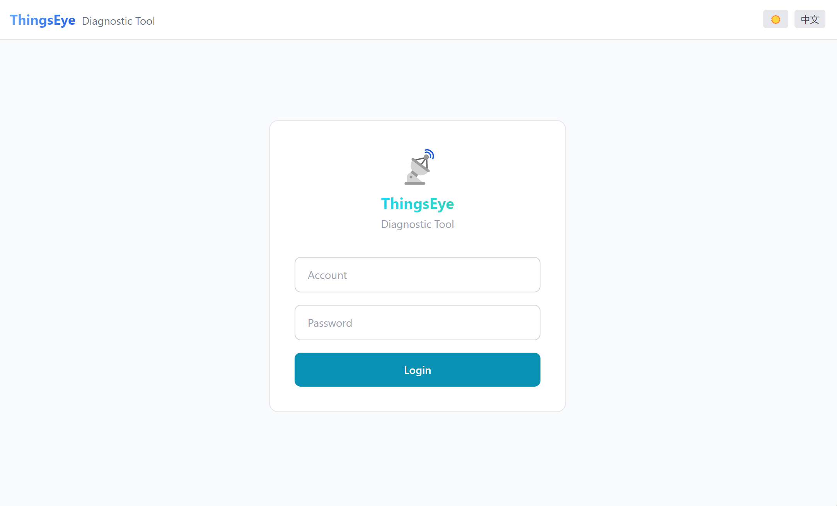
- Enter the ThingsEye username and password for the primary tenant.
- After successfully logging in, select the device type you want to diagnose: NB-IoT or LoRa.
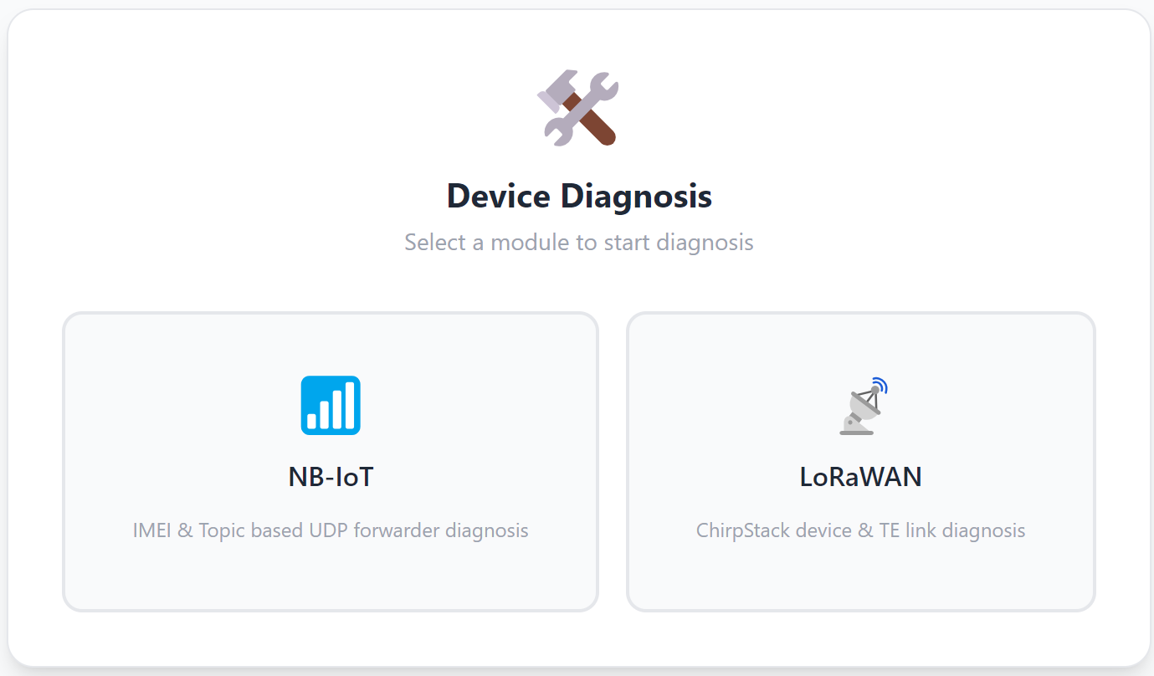
- Follow the on-screen prompts to enter or select a device, then click the “Diagnose” button to view the link test results.

- NB devices
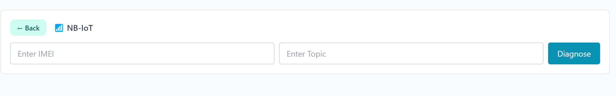
- LoraWAN devices
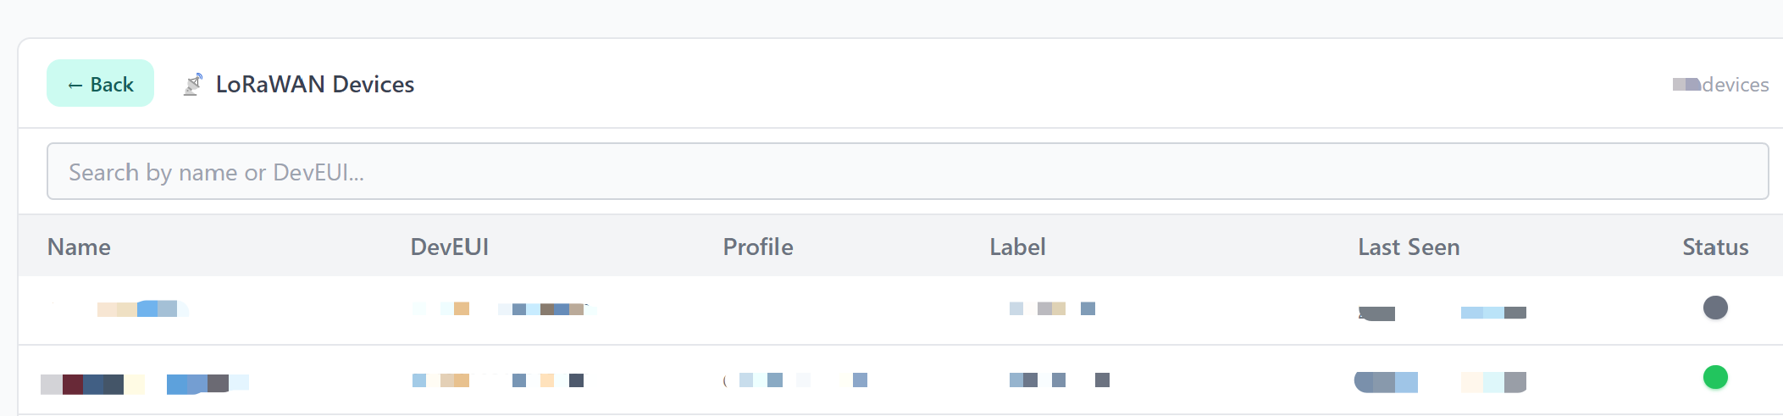

Ⅳ.NB-IoT Device Diagnostic Links
NB-IoT device diagnostics primarily check the following path:
UDP Forwarder → TE Integration → TE Converter → TE Device
Link Node | Check Item | Meaning
UDP Forwarder | Check whether IMEI, Topic, Ack Required, and forwarding records exist. | Confirm that the NB-IoT device has been forwarded by the UDP Forwarder.
TE Integration | Checks whether data has entered ThingsEye’s integration module and queries the most recent 90 days of integration events. | Confirms whether data has reached the ThingsEye integration entry point.
TE Converter | Checks whether data received by Integration has been parsed and converted by the Converter, and queries the most recent 90 days of Converter events. | Confirms whether the raw payload can be converted into ThingsEye telemetry
TE Device | Check for an exact match between the IMEI and the ThingsEye device name to verify the device’s existence, the presence of telemetry, and the last update time. | Confirm whether the final data has been added to the ThingsEye device data.

4.1 UDP Forward
- Check if the IMEI exists.
- Check if the Topic matches.
- Check the configuration status of “ACK Required.”
- Check whether the UDP Forwarder has a corresponding forwarding record.
Important Note
The registration status of the UDP Forwarder and the existence of the ThingsEye Device are two separate determinations. Even if the ThingsEye Device does not exist, as long as there is a correct record in the UDP Forwarder, the UDP Forwarder can still be marked as “Passed.”

4.2 TE Integration
The NB-IoT TE Integration is used to verify whether data has been received by the ThingsEye integration module.
- •Query integration events from the last 90 days.
- •Display only the most recent 10 detailed entries.
- •Events are collapsed by default; users can manually expand them to view details.
- •If Debug is not enabled, there may be no recent events.

4.3 TE Converter
The NB-IoT TE Converter is used to verify whether data received by the Integration module has been correctly converted into ThingsEye telemetry.
- Query Converter events from the last 90 days.
- Display only the most recent 10 detailed entries.
- Events are collapsed by default; users can manually expand them to view details.
- Converter events help determine whether payload parsing and field conversion are functioning properly.

4.4 TE Device
- Check whether a ThingsEye Device with the corresponding IMEI has been found.
- Check whether there is any historical telemetry data.
- Check the time of the most recent telemetry update.
- Display the most recent telemetry data.

Ⅴ.LoRa Device Diagnostic Links
LoRa device diagnostics primarily check the following links:
ChirpStack → ChirpStack Uplink → TE Integration → TE Converter → TE Device
Link Node | Check Item | Meaning
ChirpStack | Check if the device is registered. | Confirm that the LoRa device has been correctly created in ChirpStack.
ChirpStack Uplink | Check the time of the last uplink, the number of uplink frames, and whether ChirpStack has received data from the device. | Confirm that the LoRa network has received reports from the device.
TE Integration | Check if data is entering the ThingsEye integration module. | Confirm whether ChirpStack data has entered the ThingsEye integration gateway.
TE Converter | Check whether data has been successfully parsed and converted by the ThingsEye Converter. | Confirm whether the uplink payload can be converted into ThingsEye telemetry.
TE Device | Check whether the device exists in ThingsEye, whether there is telemetry, the time of the last update, and the data content. | Confirm whether the final data has been entered into the ThingsEye device data.

5.1 ChirpStack
- Whether the device exists.
- Basic device status in ChirpStack.

5.2 ChirpStack Uplink
- The device’s most recent uplink time.
- Uplink frame count.
- Whether ChirpStack has ever received data from the device.
- Whether the device has ever reported data normally.

5.3 TE Integration
TE Integration refers to the integration module within the ThingsEye platform, responsible for receiving data from ChirpStack or upstream services.
- Query TE Integration events from the last 90 days.
- Display only the most recent 10 detailed entries.
- Events are collapsed by default; users can expand them to view details.
- If Debug is not enabled, the latest events may not be visible.

5.4 TE Converter
TE Converter refers to the data conversion module in the ThingsEye platform, responsible for converting received raw data into ThingsEye Device telemetry.
- Query TE Converter events from the last 90 days.
- Display only the most recent 10 detailed entries.
- Events are collapsed by default; users can expand them to view details.
- Converter events are used to determine whether data has been successfully parsed and converted by ThingsEye.

5.5 TE Device
- Whether the device exists in ThingsEye.
- Whether the device has telemetry history data.
- The time of the most recent telemetry update.
- The content of the most recent data.

VI.Diagnostic Link Modules and Color Meaning
Each circle in the diagnostic link represents a module. The color and icon indicate the current status of the module.
- Green indicates that the module has passed. Common scenarios include: the device is present, data is available, telemetry is available, and the link has passed normally.
- Yellow indicates that no Integration or Converter event has been captured at this time, but the device already has telemetry; therefore, it cannot be deemed a failure. This is typically because xDebug is not enabled.
- Gray-blue indicates that the device has successfully uploaded data in the past but has not sent new telemetry for more than 48 hours; this is considered an“offline pass”status.
- Red indicates that the module has failed. A common scenario is when there are no Integration or Converter events and no telemetry from the TE Device, making it impossible to verify that data has been successfully sent to the ThingsEye platform and that the link is connected.

Status | Color | Icon | Display Text | Meaning
Passed | Green | ✓ | Pass | The current module has passed the check, and the link status is normal.
Offline but passed previously | Gray-blue | ? | Pass(offline) | The TE Device has historical telemetry, but no new telemetry has been received for over 48 hours.
No Events but Device Has Data | Yellow | ? | No Event | The Integration / Converter currently has no events, but the TE Device already has telemetry. This typically occurs when Debug is not enabled or no events have been captured recently.
Fail | Red | × | Fail | There are no events and no telemetry; it cannot be verified that data has entered ThingsEye.

Ⅶ. Integration / Converter Debug and Events Explanation
Event queries for TE Integration and TE Converter rely on debug event logs from the ThingsEye platform.
If debugging is not enabled, a situation may arise where the device actually has data, but the Integration/Converter events are empty.

7.1 Diagnostic Logic
Situation | Display Status | Meaning
No events, but the device has telemetry | Yellow ? / No Event | Device data was successfully sent to ThingsEye at some point, but no Integration/Converter event has been captured at this time.
No events and no telemetry from the device | Red × / Fail | There is no evidence that data has entered ThingsEye; the connection may have failed.
Still no events after enabling Debug | Continue troubleshooting | Check device reporting, UDP Forwarder / ChirpStack, Topic / DevEUI / IMEI, Integration configuration, Converter binding, and payload format.

7.2 Events Display Rules
- Query range: Last 90 days.
- Detailed display: Last 10 entries.
- Default state: Collapsed; can be manually expanded for viewing.
Each event typically includes the time, input data, output data, metadata, payload, error messages (if any), and the ThingsEye response (if available).

Ⅷ. Link Diagnosis and Troubleshooting Sequence

8.1 LoRaWAN Devices
- Whether the device is registered in ChirpStack.

- Whether ChirpStack has received uplinks.

- Presence of events in ThingsBoard Integration.

- Presence of events in ThingsBoard Converter.

- Presence of telemetry in ThingsBoard Device.

- Whether the latest telemetry timestamp has exceeded 48 hours.

8.2 NB-IoT Devices
- Presence of IMEI / Topic forwarding records in the UDP Forwarder.

- Presence of events in ThingsBoard Integration.

- Presence of events in ThingsBoard Converter.

- Existence of the ThingsBoard Device.

- Presence of telemetry in ThingsBoard Device.

- Whether the latest telemetry timestamp has exceeded 48 hours.

Ⅸ. Examples of Diagnostic Status
The following images show examples of common diagnostic link statuses in the app. You can determine the approximate location of the issue based on the color, icon, and text.

9.1 Examples of NB-IoT Device Diagnostic Statuses

9.1.1 NB-IoT: Entire Link Shows “Pass” (Green)
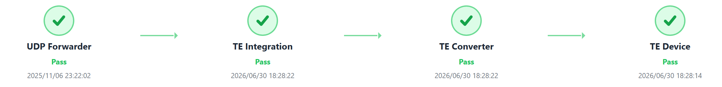
Figure 1: UDP Forwarder, TE Integration, TE Converter, and TE Device are all green “Pass.”
This diagnostic result indicates that:
- The UDP Forwarder contains valid IMEI/Topic forwarding records.
- TE Integration can receive events.
- TE Converter can convert data normally.
- The TE Device has telemetry, and the most recent data update time is normal.
Diagnostic Meaning:
- This is the most ideal diagnostic result for NB-IoT.
- It indicates that the entire chain—from UDP forwarding, ThingsEye integration, and data conversion to the final device telemetry—is functioning normally.
Recommended Checks:
- Typically, no action is required.
- If the page still shows no data, further check the dashboard display settings or time range.

9.1.2 NB-IoT: First three sections show “Pass,” TE Device shows blue “Pass”(offline)
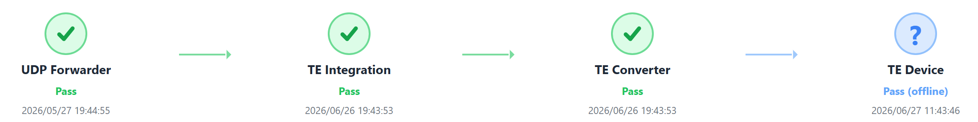
Figure 2: UDP Forwarder, TE Integration, and TE Converter show green “Pass”; TE Device shows blue “?” / “Pass”(offline).
This diagnostic scenario indicates:
- The UDP Forwarder, Integration, and Converter links are functioning normally.
- The TE Device has previously received telemetry.
- However, the TE Device has not sent new telemetry for more than 48 hours.
Diagnostic Meaning:
- This indicates that the device’s data link was previously established, but the device may currently be offline or has not reported for an extended period.
- Blue does not indicate “Fail”; it means “previously passed, but currently offline.”
Recommended checks:
- Check whether the device is powered off, has no signal, has an expired SIM card, or is experiencing network issues.
- Check whether the device is still reporting at the expected intervals.
- Confirm that there has indeed been no new telemetry in the last 48 hours.

9.1.3 NB-IoT: Integration/Converter (Yellow) — No Event, but the device passed
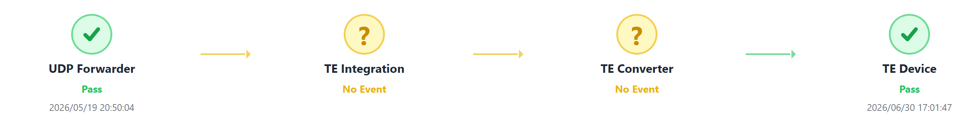
Figure 3: The UDP Forwarder shows a green “Pass,” the TE Integration / TE Converter shows a yellow “No Event,” and the TE Device shows a green “Pass.”
This diagnostic scenario indicates:
- The UDP Forwarder has forwarding records.
- The TE Device has telemetry, indicating that data was successfully sent to ThingsEye at some point.
- However, no Integration/Converter events are currently found, which typically means Debug is not enabled or no events have been captured recently.
Diagnostic Meaning:
- A yellow “No Event” does not indicate a link failure.
- Since the TE Device already has telemetry, this proves that data has previously passed through the Integration/Converter.
- There are simply no event records to display at this time.
Recommended checks:
- If you need to view event details, enable Integration Debug and have the device resubmit data.
- Check whether Debug is enabled and within the valid timeframe.
- If no events are present even with Debug enabled, check the Integration/Converter configuration.

9.1.4 NB-IoT: Entire Link Shows Red “Fail”
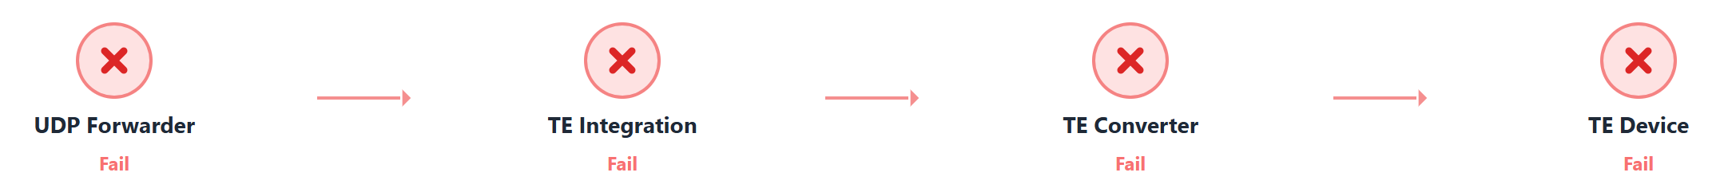
Figure 4: UDP Forwarder, TE Integration, TE Converter, and TE Device are all showing a red “Fail.”
This diagnostic scenario indicates:
- The system did not find any valid UDP Forwarder forwarding records.
- There are no events in the Integration/Converter.
- The TE Device also lacks telemetry for this IMEI.
Diagnostic Meaning:
- This indicates an NB-IoT end-to-end failure.
- This typically indicates an incorrect IMEI or Topic entry, an unregistered UDP Forwarder, or that the device has never successfully joined ThingsEye.
Recommended checks:•
- Verify that the IMEI is entered correctly.
- Verify that the Topic is entered correctly.
- Check whether the device has successfully forwarded data—that is, verify if a record for this IMEI and Topic exists in the UDP Forwarder’s background system.

9.1.5 NB-IoT: UDP Forwarder Pass, but Downstream Links Fail
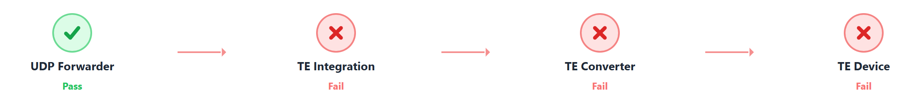
Figure 5: The UDP Forwarder is marked green (Pass), but TE Integration, TE Converter, and TE Device are marked red (Fail).
This diagnostic scenario indicates:
- There is a forwarding record for this IMEI/Topic in the UDP Forwarder.
- However, the data did not enter ThingsEye Integration or was not captured by Integration.
- The TE Device has no telemetry.
Diagnostic Meaning:
- This indicates that the UDP forwarding configuration exists, but the ThingsEye downstream link is not established.
- The issue typically occurs during Integration configuration, Topic matching, Converter binding, or ThingsEye Device creation.
Recommended checks:
- Check if the device is activated and sending data packets.
- Check if the Integration’s Topic matches and if the correct Converter is bound.
- Check if the Converter can parse the payload.

9.1.6 NB-IoT: UDP Forwarder Pass, but Downstream Links Fail
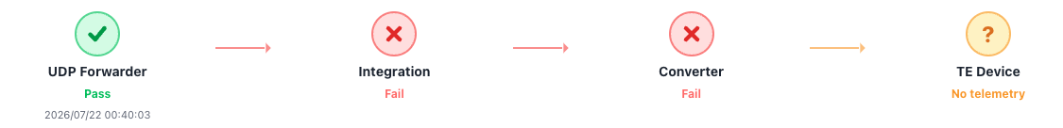
Figure 6: The UDP Forwarder is marked green (Pass), TE Integration and TE Converter are marked red (Fail), and TE Device is marked orange (No telemetry).
This diagnostic scenario indicates:
- There is a forwarding record for this IMEI/Topic in the UDP Forwarder.
- The UDP Forwarder has received or forwarded data, as indicated by the recorded timestamp.
- However, the data did not successfully enter ThingsEye Integration or was not captured by the configured Integration.
- Because Integration failed, the Converter was not triggered or could not process the payload.
- The TE Device exists in the diagnostic flow, but no telemetry has been written to the device.
Diagnostic Meaning:
- This indicates that the device-side UDP forwarding path is available, but the ThingsEye downstream processing chain is not completed.
- The issue usually occurs after UDP Forwarder registration, especially in Integration Topic matching, Converter binding, payload decoding, or telemetry writing.
- “No telemetry” means ThingsEye has not received valid telemetry for the device, even though the UDP Forwarder side shows Pass.
Recommended checks:
- Check whether the IMEI and Topic configured in the UDP Forwarder exactly match the Integration configuration.
- Check whether the Integration is enabled and listening to the correct Topic.
- Check whether the correct Converter is bound to the Integration.
- Check whether the Converter can parse the NB-IoT payload format correctly.
- Check whether the TE Device name exactly matches the IMEI and is created under the correct tenant/account.
- Check Integration and Converter debug logs to confirm whether the payload enters ThingsEye and whether parsing succeeds.

9.2 Examples of LoRaWAN Device Diagnostic Statuses

9.2.1 Integration/Converter shows yellow“No Event,” but the device shows“Pass”
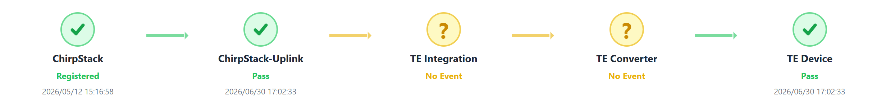
Figure 7: ChirpStack Registered, ChirpStack-Uplink Pass, TE Integration / TE Converter shows yellow “No Event,” and TE Device shows green “Pass.”
This diagnostic scenario indicates:
- The device is already registered with ChirpStack.
- ChirpStack has received the uplink.
- The TE Device has telemetry.
- However, there are currently no event records for Integration / Converter.
Diagnostic Meaning:
- This indicates that the LoRa device and uplink are generally functioning normally, and the TE Device ultimately has data.
- The yellow status in the middle typically indicates that Debug is not enabled or that no Integration/Converter events have been captured recently.
Recommended checks:
- If you need event details, enable Debug and then trigger the device to report again.
- Check whether Integration/Converter debug is enabled.
- If there are still no events after enabling Debug, check the integration configuration between ChirpStack and ThingsEye.

9.2.2 LoRa:Full-Link Green Pass
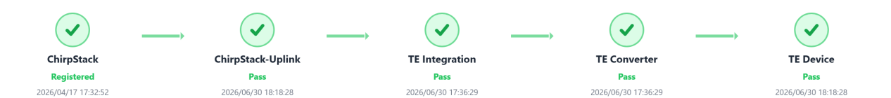
Figure 8: ChirpStack, ChirpStack-Uplink, TE Integration, TE Converter, and TE Device are all green (Pass).
This diagnostic scenario indicates:
- The device is registered with ChirpStack.
- ChirpStack has recently received an uplink.
- There are events in both ThingsEye Integration and Converter.
- The TE Device has the latest telemetry.
Diagnostic Meaning:
- This is the ideal diagnostic result for a LoRa device.
- It indicates that the entire data transmission path from the LoRa network to the ThingsEye device is functioning normally.
Recommended checks:
- Usually, no action is required.
- If the dashboard still shows an anomaly, check the dashboard configuration, time range, or field mapping.

9.2.3 LoRa: Integration/Converter shows yellow “No Event,” device shows blue “Pass”(offline)
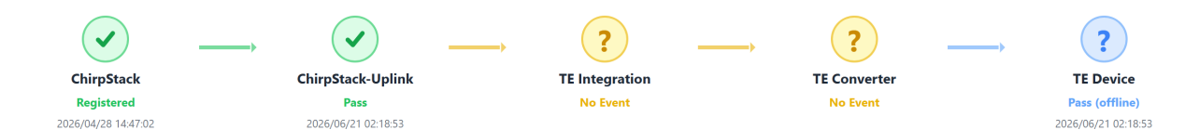
Figure 9: ChirpStack Registered, ChirpStack-Uplink Pass, TE Integration / TE Converter shows yellow “No Event,” TE Device shows blue “Pass”(offline).
This diagnostic scenario indicates:
- Registration and uplink on the ChirpStack side are normal or were previously normal.
- The TE Device has historical telemetry.
- However, the TE Device has not updated its telemetry for more than 48 hours.
- The Integration / Converter currently has no events.
Diagnostic Meaning:
- This indicates that the device has previously successfully connected to ThingsEye but is currently offline or has not reported for an extended period.
- Yellow“No Event”indicates that no intermediate events are currently being captured;blue“Pass(offline)”indicates that the end device has historical data but no recent data.
Recommended checks:
- Check whether the LoRa device is still powering on and sending packets.
- Check whether the gateway is online and coverage is normal.
- Enable Debug mode and retrigger the report to confirm whether the Integration / Converter has a new event.

9.2.4 LoRa: ChirpStack Registered, but Uplink and Subsequent Links Fail
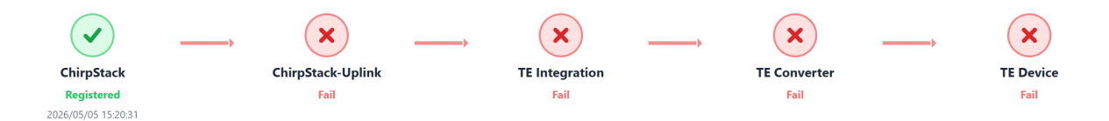
Figure 10: ChirpStack is green (Registered), but ChirpStack-Uplink, TE Integration, TE Converter, and TE Device are all red (Fail).
This diagnostic scenario indicates:
- The device exists in ChirpStack, indicating that registration information is present.
- However, ChirpStack has not received a valid uplink.
- Consequently, the subsequent Integration, Converter, and TE Device stages all fail.
Diagnostic Meaning:
- The issue typically occurs at the LoRa device reporting stage or on the LoRa network access side.
- The presence of the device does not mean it is activated and sending packets normally.
Recommended checks:
- Verify that the device’s DevEUI, App Key, and Join Key are configured correctly.
- Check whether the device has successfully joined the network, is powered on, and is transmitting packets at the scheduled intervals.
- Check whether the gateway is online and whether signal coverage is normal.
- Confirm whether ChirpStack has any recent uplink records

9.2.5 LoRa: ChirpStack Registered, but Uplink and Downstream Links Fail with No Device Event
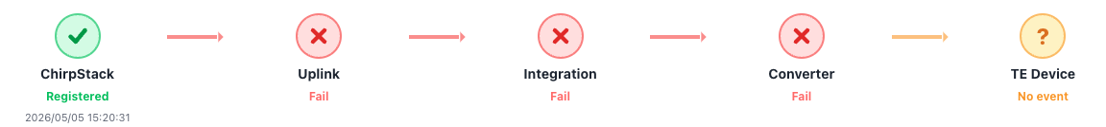
Figure 11: ChirpStack is green (Registered), ChirpStack-Uplink, TE Integration, and TE Converter are red (Fail), and TE Device is orange (No event).
This diagnostic scenario indicates:
- The device exists in ChirpStack, indicating that registration information is present.
- However, ChirpStack has not received or captured a valid uplink event from the device.
- Because no valid uplink is available, the data cannot be forwarded to ThingsEye Integration.
- As a result, the Converter is not triggered, and no device event is generated in ThingsEye.
- The TE Device stage shows “No event”, meaning no valid device-side event has been created or recorded.
Diagnostic Meaning:
- This indicates that the LoRa device is registered in ChirpStack, but the actual reporting chain has not started successfully.
- The issue usually occurs before ThingsEye processing, especially at the device activation, join, transmission, gateway, or ChirpStack uplink stage.
- “Registered” only confirms that the device record exists in ChirpStack; it does not confirm that the device has joined the network or sent uplink packets successfully.
- “No event” means ThingsEye has not received a valid upstream event from the LoRa chain.

Recommended checks:
- Verify that the device’s DevEUI, App Key, Join Key, and application settings are configured correctly.
- Check whether the device has successfully joined the LoRaWAN network.
- Confirm that the device is powered on and sending uplink packets at the expected interval.
- Check whether the gateway is online and whether signal coverage is normal.
- Confirm whether ChirpStack has recent uplink records for this device.
- · If ChirpStack has no uplink records, troubleshoot the device, gateway, and LoRa network first before checking ThingsEye Integration or Converter.

